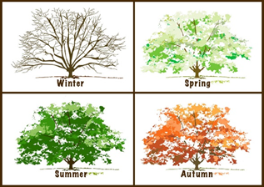
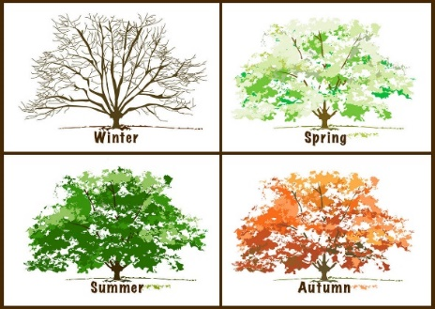
Science Home Learning Grid
Light and Astronomy – Seasonal Changes

KNOWLEDGE ORGANISER |  | WEEK 1
The knowledge organiser contains details of learning for this topic.  Within the knowledge organiser, the vocabulary dozen contains key words to learn to define, spell and use during this learning. |  | What is the weather like today?  Make a weather diary – see attached resources  https://www.bbc.co.uk/bitesize/clips/z9g87ty
WEEK 2 | WEEK 3 | WEEK 4  Nature Journal
Identifying seasons  https://www.bbc.co.uk/bitesize/articles/zhtp2v4  complete online games and quiz | Create your own weather vane. Can you tell which direction the wind is blowing?  (see attached instructions) | Looking for signs of Autumn  Can you find a seed? Conker, acorn, sycamore seed pod.  Find out the name of the tree it comes from?  Draw the seed, the leaf from the tree and name the tree.
WEEK 5 | WEEK 6 | WEEK 7
Choose 2 seasons and compare them.  Talk about daylight hours/temperatures/trees/clothes worn/weather | Create a season wheel and draw a picture of each season inside  (see attached instructions) | Choose 3 challenge card questions to complete  (attached)

