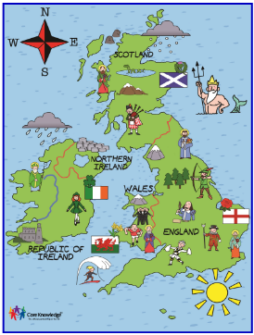
Geography Home Learning Grid

KNOWLEDGE ORGANISER |  | WEEK 1
The knowledge organiser contains details of learning for this topic.  Within the knowledge organiser, the vocabulary dozen contains key words to learn to define, spell and use during this learning. |  | I can name and label UK countries  https://www.bbc.co.uk/bitesize/topics/zyhp34j/articles/z4v3jhv
WEEK 2 | WEEK 3 | WEEK 4
I can label the capital cities in the United Kingdom  https://www.bbc.co.uk/bitesize/articles/z42pnrd  Watch the clip and write something about what you might find or see if you visit the 4 capital cities | Sort the picture cards into physical or human features  See resources section | Human Geography (man-made)  Make a list of the human features you have discovered in the UK.
WEEK 5 | WEEK 6 | WEEK 7
Physical Geography (natural)  Make a list of the human features you have discovered in the UK. | Visit OS website to help you to recognise the symbols and complete attached activity. | Create your own map of your area  Make sure your map has a title and key.

Extra activities
Create an information booklet about one of the capital cities to visit.

