Home Activities to Develop Gross Motor Skills
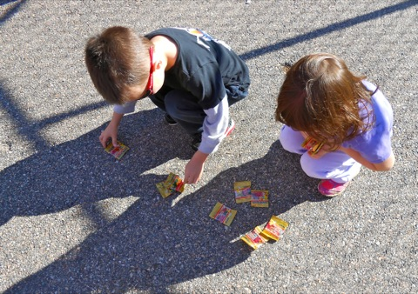
Chalk
Chalk wavy, curved or zig zag lines outside and get the child to follow the pattern when walking, running, hopping, skipping or whilst riding a bike.
Clapping games
Alternating the rhyme and speed. Slow, fast 2 claps then 4 claps etc.
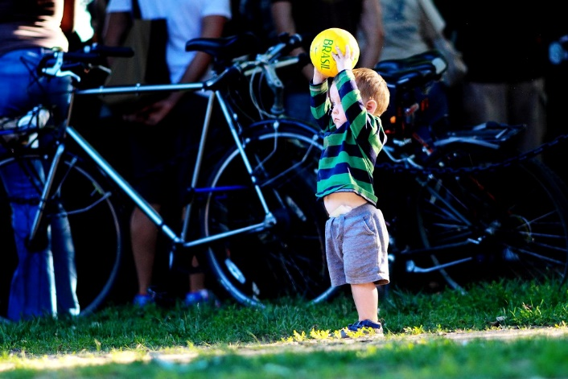
Bounce a Ball
Outside. Bounce a ball using your left hand then right hand and then both hands alternately. Try to keep rhythm going.
Bubble wrap Activities
Roll out bubble wrap let children roll along it.
Walk popping with toes.
Give a small piece of bubble wrap and let them wring it out forwards and backwards until all bubbles are popped.

Balloon Activities
From a standing position, throw a ball up and down and catch with both hands together.
Whilst running or walking around, throwing the balloon into the air, and by tapping it upwards try to prevent it going on the floor.
While walking forwards, bounce the balloon on the floor using both hands alternately.
Ribbon Activities
Tie Ribbons to a stick with right hand and then swop over to left hand, grip the handle and with big circular movements, twirl the ribbon from left to right.
With both arms outstretched, grip the handle in both hands and make a large figure of 8 crossing the midline from left to right.
To increase the difficulty, as the children become used to using the ribbons, include walking, running and skipping whilst twirling the ribbon.

